Cedar Ridge High School
VOLLEYBALL BOOSTER CLUB
Spirit Items Order Form
ALL ORDERS ARE DUE BY SEPT 21st
Color and style may change  (no # on ball) | 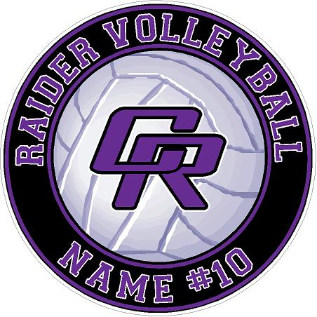
Gym Spirit Ball  (hangs in gym)  $30  Quantity______ | Car Window Decal  $5  Quantity______ | Yard Sign  $22  Yard Stake $2  Quantity______
Circle One:  CASH CHECK PAYPAL* | Total Amount Paid: $ | Payment Received By:  Date Received:

Athlete Name Athlete Number

Team: Please circle one Graduation Year: Please circle one

VARSITY JV FLEX FRESHMAN 2021 2022 2023 2024

Parent/Guardian Name Phone # Email Please provide all information above and write legibly so we can contact you if there are questions about your order.
Preferred Payment: Please make your check payable to: Cedar Ridge Volleyball Booster Club or CRVBC.
*For PayPal, go to the Booster Club page of the website - crhsraidersvolleyball.com - and click the Donate button. Please indicate in the PayPal note what your payment is for - “Spirit Items”.

