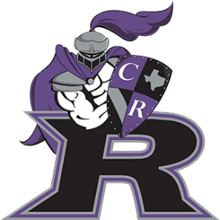
Cedar Ridge High School
VOLLEYBALL BOOSTER CLUB

Raider Raves Form
2020-2021

Raider Raves are special messages for your athlete that will appear in the season program.

Rave Specs: Color or Black & White (see Raider Rave examples on the next page)
Rave Size: Select from the options below
File Type: Publication-ready digital ad as a Word (.doc), Publisher (.pub), PNG or JPG file

____ FULL PAGE (7.5” wide x 10” tall) - $100
____ HALF-PAGE (7.5” wide x 5” tall) - $50
____ QUARTER-PAGE (3.75” wide x 5” tall) - $25
All ads must meet the exact size specifications listed above and are subject to approval by the Booster Club.
RAVE DEADLINE IS SEPTEMBER 21st
Please email your Rave file to crhsraidersvb@gmail.com and turn in this form with payment to a Booster Club Board Member or at the Spirit Table in the main gym during home games.

Contact Information: Please write legibly.

Athlete Name and Number Grade

Parent/Guardian Name Email

Form of Payment (circle one) CASH CHECK PAYPAL*

Total Amount Due

Preferred payment: Please make your check payable to: Cedar Ridge Volleyball Booster Club or CRVBC.
*For PayPal, go to the Booster Club page of the website - crhsraidersvolleyball.com - and click the Donate button. Make sure to indicate in the PayPal note what your payment is for - “Raider Rave - <insert player name>”.

Booster Club Use Only:
Amt Recv’d: Recv’d By: Date Recv’d: Check # Cash

Raider Rave Examples
HALF PAGE AD
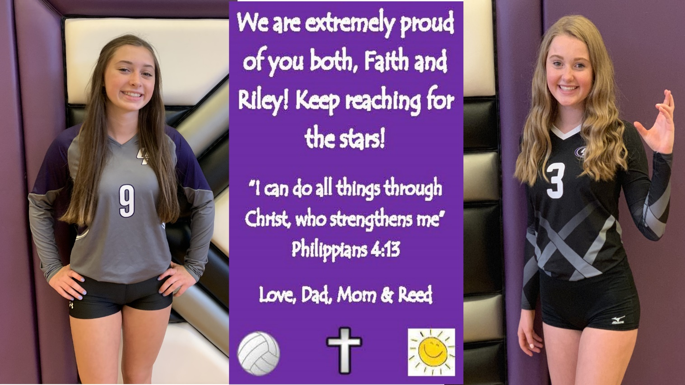
QUARTER PAGE AD
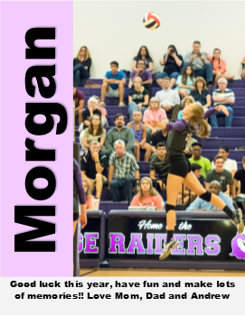
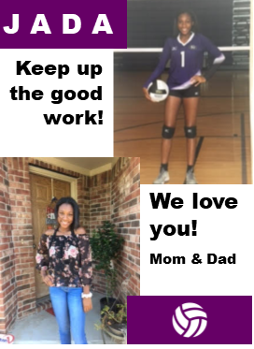

FULL PAGE AD
